### Redeem Google Cloud Credits:

Access our class's [Student Coupon Retrieval Link](https://gcp.secure.force.com/GCPEDU?cid=4SoxhqyZAL5ECuXxwMNRhIchP%2BfuuSW5%2B02np%2BM9lOfnuVKUE5zwVJ0mw0XQJyzO/) to request a Google Cloud coupon. You will be asked to provide your school email address and name. Please use an email address from @columbia.edu or @barnard.edu (if you don't have such an address for some reason, contact the instructors on Ed). An email will be sent to you to confirm these details before a coupon is sent to you. Each student can only acquire a single credit for this assignment. Please contact us if you have any questions or issues.

### Get access to the image for the project:

To get started, you have to launch an instance of the VM image that has the infrastructure you need for the projects. The image will give you the starter files and make sure that you develop and test your code in the same environment that we will use to grade.

Here are the steps to follow:

1. Go to <https://console.cloud.google.com/projectselector2> to create a new project with any name. When you create the project, you should select ‘Billing Account for Education’ as Billing Account in order to use your credits [If you just use your coupon for this project, it should provide sufficient funding. Please alert us as early as possible if you are having problems with the coupon not covering your expenses]. Go to <https://console.cloud.google.com/apis/api/compute.googleapis.com/> to enable the Compute Engine API.
2. Go to the [IAM page](https://console.cloud.google.com/iam-admin/iam/) in the Google Cloud console of your project. Remember to use the project that you would like to have access to the image.
3. Look for Google APIs service account, which has an email address in the format: **[PROJECT_NUMBER]@cloudservices.gserviceaccount.com**

(In other words, find the email address circled in red.)

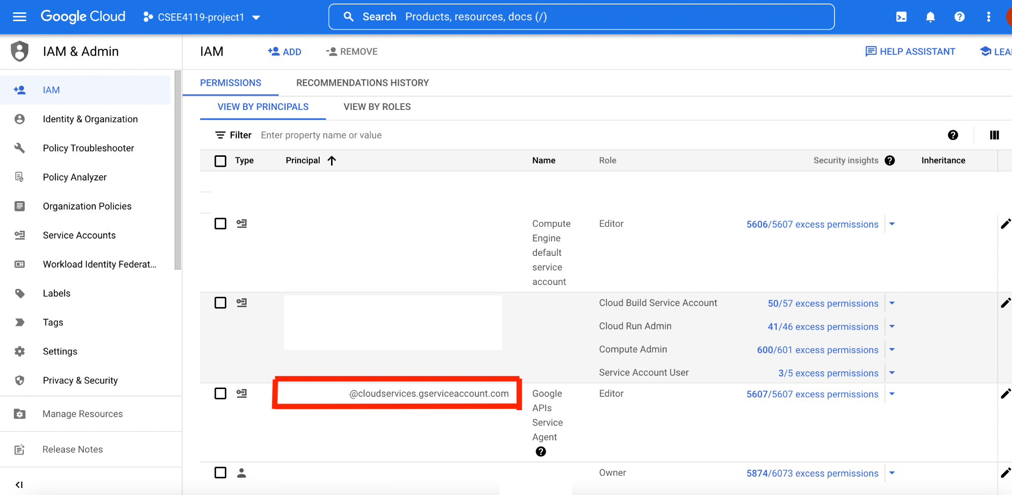

1. Fill out the [form](https://docs.google.com/forms/d/e/1FAIpQLSc4iNQjztt35JRw2zUiWu64lE1JBGSmrknW0BgrSuCmr82Hxw/viewform?usp=sf_link) and **wait** until you are notified of having access to the image.

### Create an instance using the image:

1. Go to the google cloud shell of your project. You can access it by clicking the button shown in the figure below.

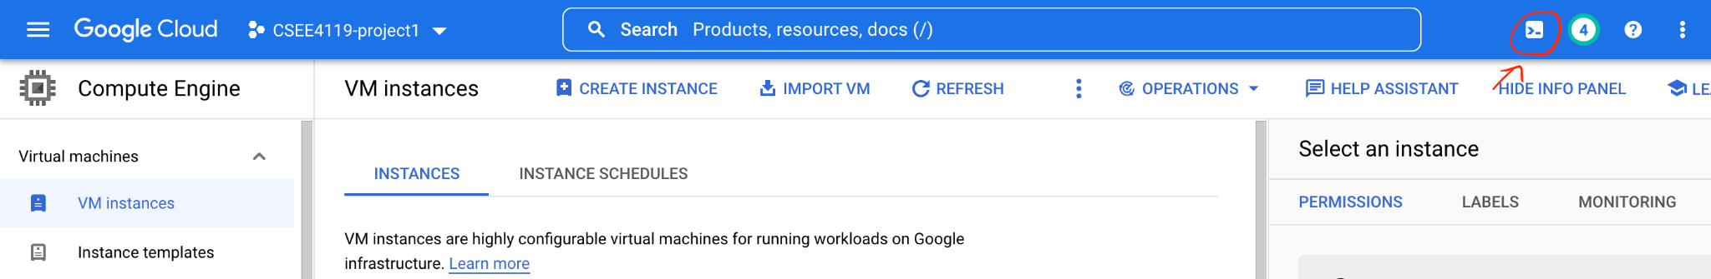

1. Create a configuration file ‘vm.yaml’ with the following content in the gcloud shell. You can modify the name to any name you want to have for your vm instance. You can also modify the machine type if you want more CPU or memory.

Detailed commands for whom not familiar with shell and vim:

1. vim vm.yaml
2. In the opened vim editor, type “i” to enter INSERT mode
3. Copy the contents below then paste in the vim editor
4. Press esc and type “:wq” then press “enter” to save the file.

resources:

- name: abr-project-vm-1

type: compute.v1.instance

properties:

zone: us-central1-a

machineType: zones/us-central1-a/machineTypes/n1-standard-1

tags:

items: ["http-server", "https-server"]

disks:

- deviceName: boot

type: PERSISTENT

boot: true

autoDelete: true

initializeParams:

sourceImage: projects/csee4119-project1-361403/global/images/fall22-csee4119-image

networkInterfaces:

- network: global/networks/default

accessConfigs:

- name: External NAT

type: ONE_TO_ONE_NAT

1. Run the following command in the gcloud shell. Notice that the name of the deployment (‘my-first-deployment’ in the command below) and the name of the VM (‘abr-project-vm-1’ specified in the .yaml file) have to be changed if you want to use the command to import a second instance.

gcloud deployment-manager deployments create my-first-deployment --config vm.yaml

1. Reload your web page, and you should have an instance named ‘abr-project-vm-1’ in your Compute Engine > VM instances. (You can click the three horizontal lines on the upper left corner and navigate to Compute Engine > VM Instances to find your list of instances.)

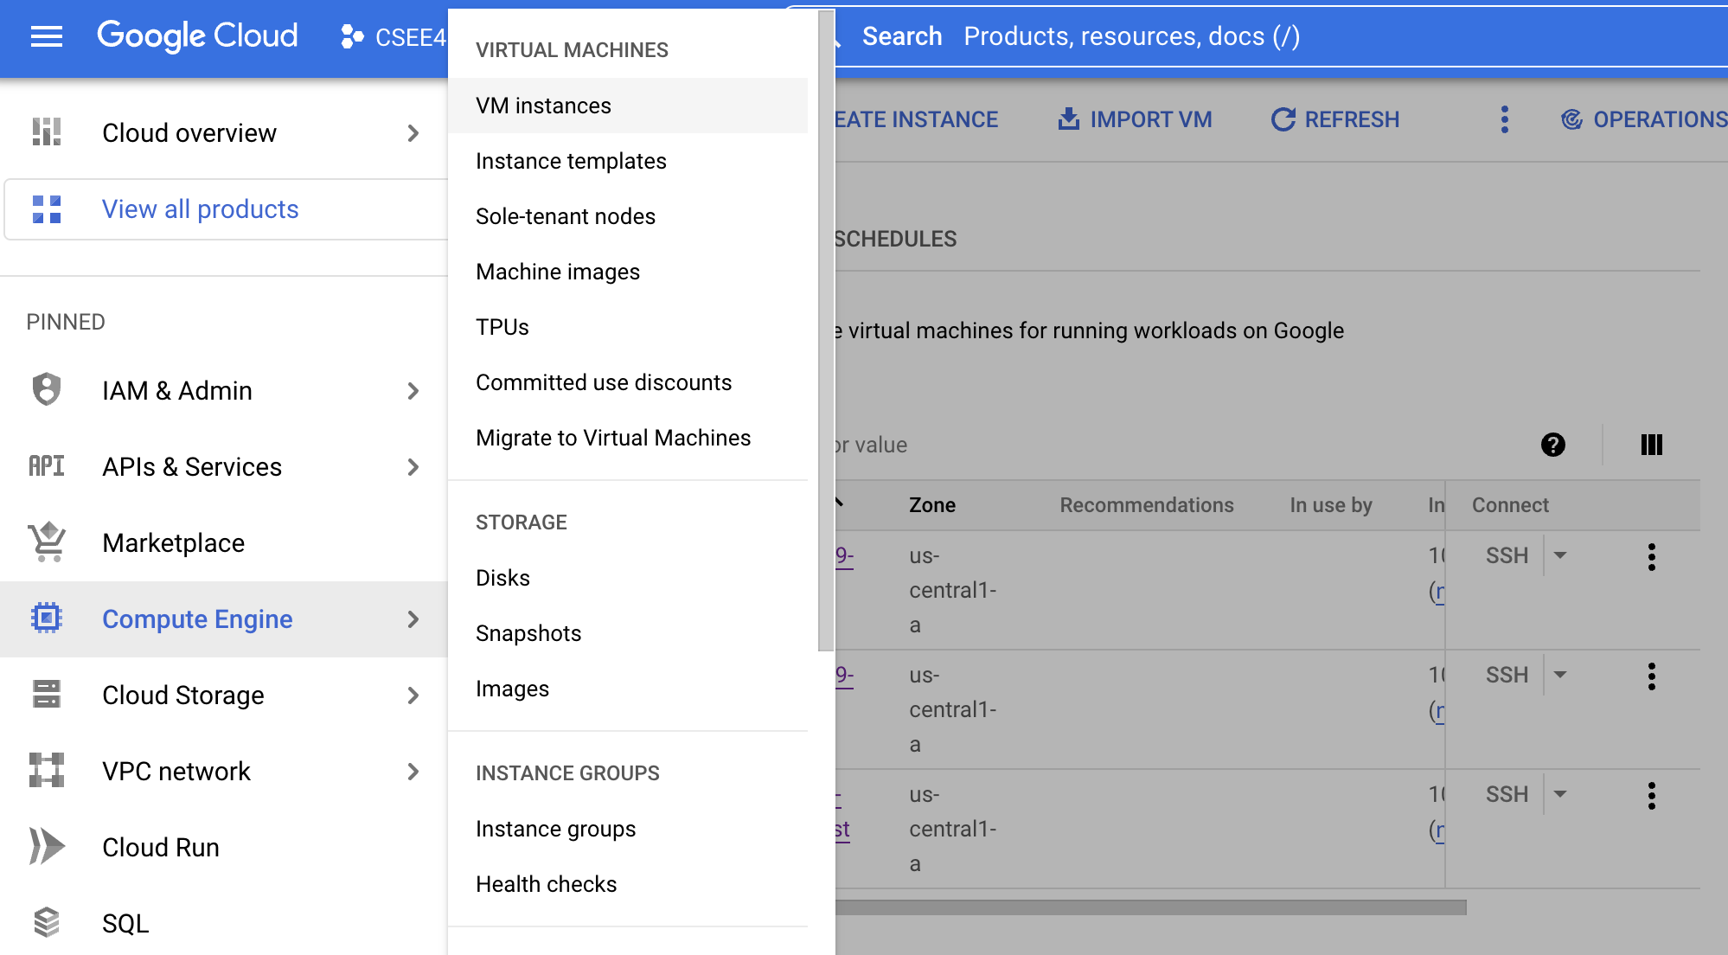

You can ssh to it (by clicking the SSH button), and in the instance you will find the folder ‘csee_4119_abr_project’ under the directory ‘/home/sy3011’. **Run ‘cp -r /home/sy3011/csee_4119_abr_project ~/’ to copy the folder to your own user directory.**

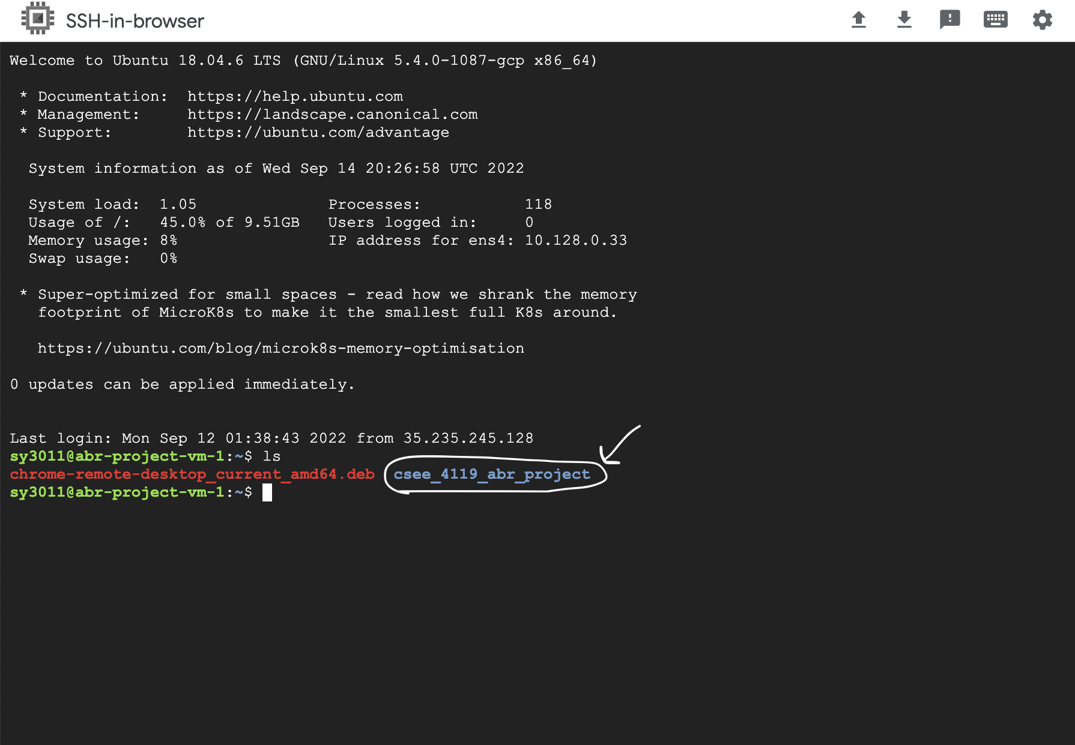

NOTE: The instance is connected to the Internet. You should be able to create your own github repo and push your code. You can also upload and download files by using the **↑** and ↓ buttons on the top of the SSH-in-browser window.

**Please remember to stop your VM when you don’t need it to save costs (so the coupon we gave you will last for the class project and beyond). (But don’t delete your VM!)**

### Launch Ubuntu Desktop:

1. SSH to your VM instance. Run the following commands **ONE BY ONE** in your VM instance:

sudo tasksel install ubuntu-desktop

sudo bash -c 'echo "exec /etc/X11/Xsession /usr/bin/gnome-session" > /etc/chrome-remote-desktop-session'

1. Reboot the machine by running ‘sudo reboot’ in your instance. Close the SSH window, and wait a minute and SSH into it again.
2. Using the Chrome browser on your local computer, go to the [Chrome Remote Desktop page](https://remotedesktop.google.com/headless).
3. Click ‘Begin’, ‘Next’, and ‘Authorize’ until reaching the following page.

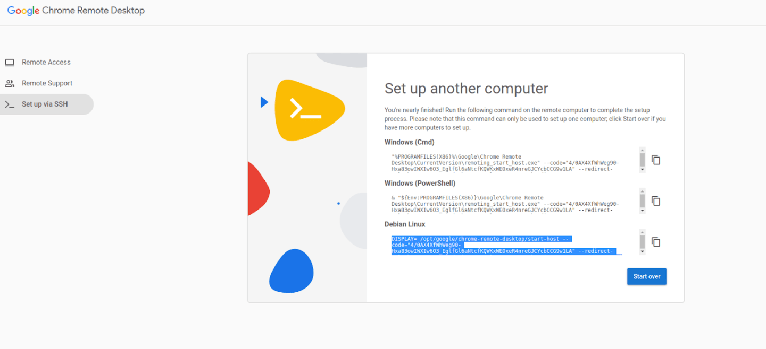

1. Copy the command under ‘Debian Linux’ and paste it into your VM instance. Run the command. Enter a 6-digit PIN.
2. Go to <https://remotedesktop.google.com/access> and you will find your instance. Click to connect to it and enter your PIN.

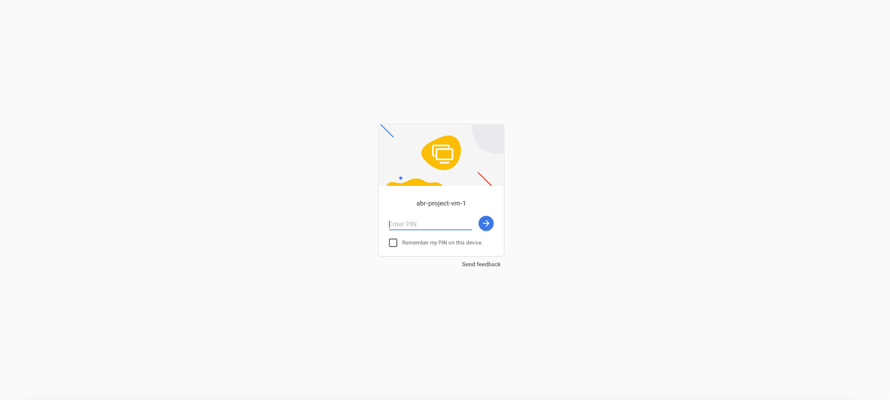

1. If you see the following page, just cancel it.

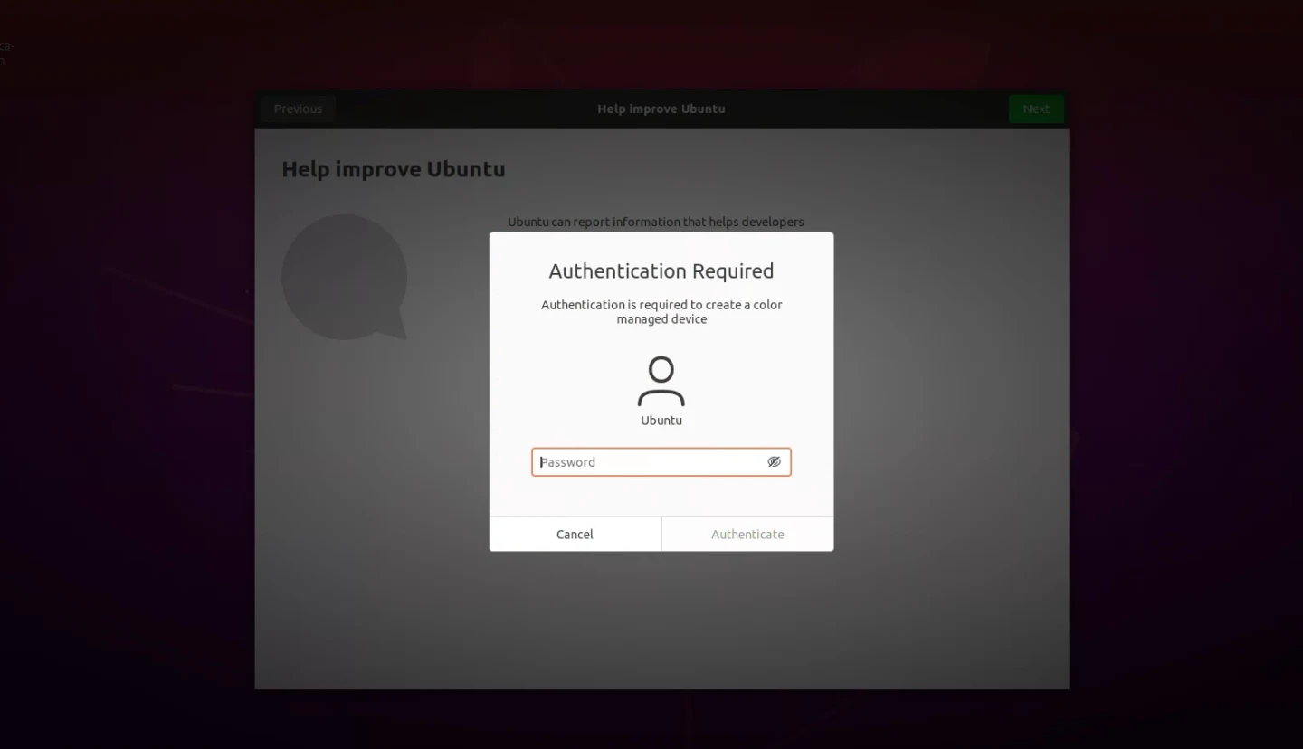

1. You are now able to use the browser to test if your instance can connect to the Internet. If you can, you're all set to work on the project!

NOTE: After setting up the connection once, you can access your remote VM instance with step 6-7. Sometimes Google remote desktop is stuck on starting, which usually happens due to a glitch in the Chrome or Remote Desktop app. You can fix it by restarting your VM. (If it still does not work, you can reset the connection, i.e. clicking the delete button and redoing steps 3-8.)

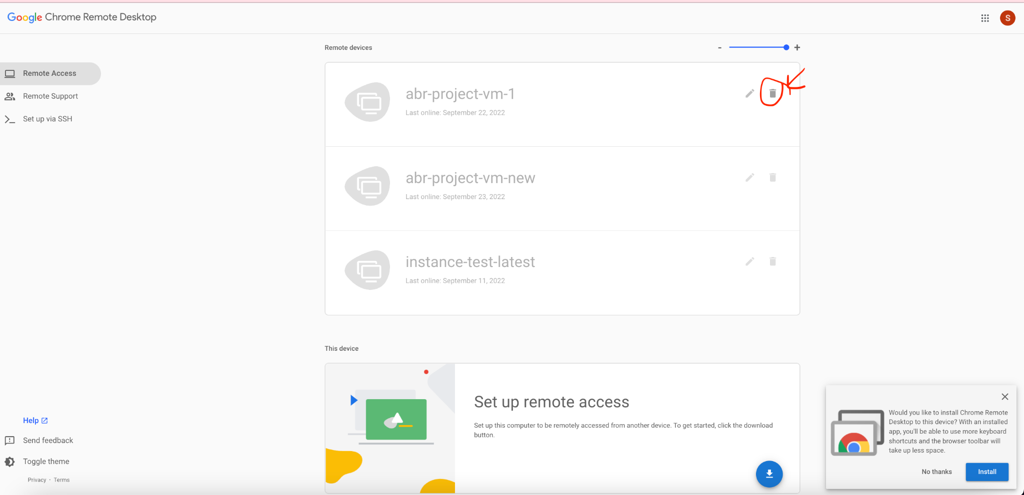

NOTE: You can use sidebar options to upload/download files.

